Maximum Gain and Maximum Loss Chart
Position | Maximum Gain | Maximum Loss
Long Call | Unlimited | Premium
Short Call | Premium | Unlimited
Long Put | SP-Premium=BE | Premium
Short Put | Premium | SP-Premium=BE
SP=Strike Price BE=Break Point Point
The following is a quick review of how to calculate when an investor breaks even on the most common option trading strategies.
Call Buyer-The exercise price plus the premium paid.
Put Buyer-The exercise price minus the premium paid
Covered Call Writer-The cost to purchase the long stock position, minus the premium received.
Naked Call Writer-The exercise price plus the premium.
Put Writer-The exercise price minus the premium.
Call Spread-The lower strike price plus the net of the debit or credit.
Put Spread-The higher strike price minus the net debit or credit.

Long Call Butterfly
Butterfly's are three legged option combinations.
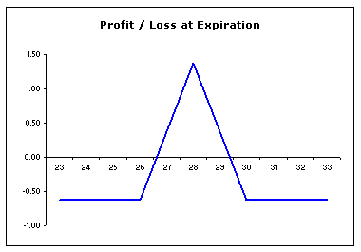
Components
Short two ATM call options, long one ITM call option and long one OTM call option.
Risk / Reward
Maximum Loss: Limited to the ATM strike less the ITM strike less the net premium paid for the spread.
Maximum Gain: Limited to the net premium received from the spread.
Characteristics
When to use: When you are neutral on market direction and bearish on volatility.
With a long butterfly your losses are limited. This means that you make money when the market remains flat over the life of the options.
You might be thinking that it looks like a "short" strategy because of the similarity to the short straddle. You are right in thinking that they have similar characteristics, however, the difference between a Long Butterfly and a Short Straddle is the premium - a Long Butterfly will cost you money (or premium) to establish whereas a Short Straddle won't cost you anything as you receive money (premium) up front for putting on the position.

